בס"ד

**Road Signs Classiftcation**

Itamar Ziv-On

Ori Ben-Hamo

Boaz Sharabi

*Ariel University, Ariel, Israel*

Keywords: Road Signs Recognition, Convolutional Neural Network, Deep Learning

Abstract: Road signs classification play an important role in the unmanned automatic driving. In this paper, a road signs classification method is presented based on Convolutional Neural Network. In this method, each image is represented by grayscale value pixels as features and a number related to its road sign name as the image label.

The method is used for classification based on the extracted features. The experimental results show that the method achieves a very good performance on road signs classification, with a high 99.946 % accuracy rate.

# INTRODUCTION

Nowadays, unmanned automatic driving technology has attracted increasing attentions from researches and industry communities. The road signs classification play an important role in this field. For this purpose, it is possible to use several tools.

This paper will show the use in Logistic Regression , Neural Network(NN) the use in Convolutional Neural Network (CNN) and the comparison between this three tools.

This article expand and show the different results depending different models.

.

Raw Images

ROIs

Preprocessing

Feature Extraction

Testing Images

Training Images

Classification

# RELATE WORK

To solve the target recognition problem, most of the previous works use hand-crafted feature extracting methods mentioned in Section 1. Those conventio- nal feature extraction methods, over-reliant on the de- signer’s experience, meet some restriction in feature expression. On the contrary, the deep network mo- del based on CNN is more powerful in feature ex- pression. CNN method, which possessing the cha- racteristics of rotation, translation and scaling inva- riance, is able to realize weight sharing through lo- cal receptive fields. It’s widely used in the sub-area of target recognition, e.g., image classification (Kri- zhevsky et al., 2012) (Schmidhuber, 2012), face re- cognition (Sun et al., 2014) (Li et al., 2015) and pe- destrian detection (Ouyang and Wang, 2014) (Zeng et al., 2013). Afterwards, various CNN-based mo- dels have been proposed, such as AlexNet (Krizhe- vsky et al., 2012), VGG (Simonyan and Zisserman, 2014) , GoogleNet (Szegedy et al., 2015), ResNet (He et al., 2016) and so on. The VGG network model has been widely used and improved by researchers thanks to its multi-layer construction and excellent perfor- mance on the most representative data set in target re- cognition field which named ImageNet (Krizhevsky et al., 2012). Based on this, some famous network models, e.g., the R-CNN series (Girshick, 2015) (Ren et al., 2017), YOLO (Redmon et al., 2016), SSD (Liu et al., 2016), R-FCN (Dai et al., 2016), appears in succession.

# FRAMEWORK AND EXPERIMENTAL DATA

## Framework of CNN-SVM Method

Figure 2 shows a process diagram of the working pro- cedures of CNN-SVM. The CNN-SVM method can be concluded as the following six steps:

* + - Training images and testing street-view images

Result

Figure 2: Framework of Road Signs Recognition.

are collected, and then the training images are la- beled and transformed in YCbCr color space.

Visual features of these training images are ex- tracted in CNN.

•

A SVM classifier is used to classify the training images based on the extracted features.

•

Testing street-view images are sent to preproces- sing progress, including homomorphic filter, mor- phological treatment and area threshold segmen- tation.

•

Region of Interest (ROIs) in street view are acqui- red and delivered to CNN-SVM model.

•

* Detection and classification results are obtained.

## Experimental Data

Eight kinds of signs, individually from the warning signs, prohibition signs and mandatory signs, are ta- ken into consideration in our research. The trai- ning images mainly consists of mobile phone shoot- ings, GTSDB and Baidu exploration. These images, through some transformation like rotating and affine transformations, reach a total number of 1000. Each image is unified with the size of 48 48. Then, these images are labeled and composed as a training data set which is shown in Figure 3. The testing street-view images comes from 4 videos, which are captured by PIKE F-100 FireWire camera. Each frame size of the

×

videos is 1920×1080.

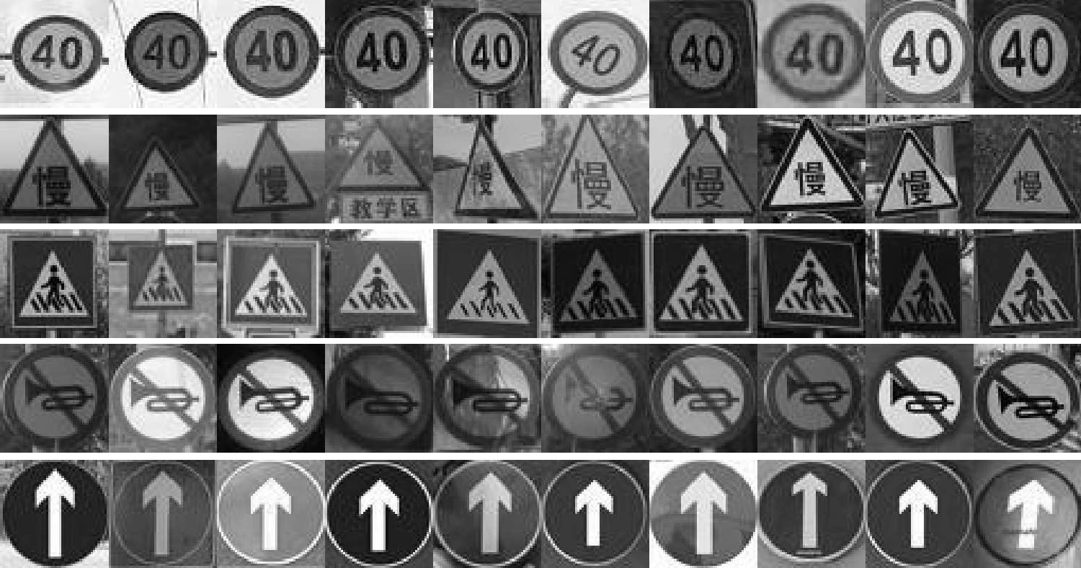

Figure 3: Road Signs Training Data Set.

*fx bx Cx*



 *X* L

*Sx*+1

·

Img

*wx*+1 *bx*+1

* + - Calculate the deviation matrix of the output. Conduct a layer-by-layer reverse calculation ac- cording to gradient descent algorithm.

Figure 4: The Diagram of Convolution Progress. An input

•

sample with the size of 48 48 is convoluted with a 5 5 convolutional kernel. Then, six 44 44 feature maps are ge- nerated. Each neuron in the feature map is connected with

×

× ×

5 5 convex kernel. After the summation of each group of pixels in the feature map, the weight and offset are added. After taking activate function, the neurons in the next layer are automatically acquired. Naturally, the next volume can be obtained by continuous translation and traverse opera- tion.

×

# CONVOLUTIONAL NEURAL NETWORK TRAINING BASED ON YCBCR COLOR SPACE

## Convolutional Neural Network

Our basic model follows the classic LeNet-5 network, which consists of three convolutional layers (*C*1, *C*3 and *C*5) and two sub-sampling layers (*S*2 and *S*4). The input of each layer represents a small group of local units from the upper layer. Each convolution layer contains multiple convolution kernels. These convo- lution kernels are able to scan the image features via different expressions, based on this, we can acquire various feature maps in different locations. The sub- sampling layer, following the convolution layer, is mainly used to reduce the resolution of the feature map, to extract the existing image features and to de- termine the features’ relative location.

## CNN Training

The training of the layer-concatenated CNN includes 4 main parts, i.e., forward propagation, error calcula- tion, back propagation and weights adjustment. The

* Acquire the updated weight and gradient values. Repeat the forward propagation to start the next iteration.

## YCbCr Color Space for CNN’s Feature Extraction

•

The previous road signs recognition and classifi- cation methods usually take CNN training in RGB space. In that space, the color information and the lu- minance information are mixed among channels, ge- nerating the variance of the extracted features. No- netheless, the color distribution in RGB space is not uniform. Some subtle changes in color are captured difficultly.

YCbCr color space is mainly used for continuous image processing in the video. We can calculate each component by the transform formula shown as:

*Y* = 0*.*299*R* + 0*.*587*G* + 0*.*114*B* (1)

*Cb* = 0*.*564(*B* − *Y*) (2)

*Cr* = 0*.*713(*R* − *Y*)*,* (3)

where Y is luminance component, Cb represents the blue chrominance component and Cr denotes the red chrominance component.

In order to choose a better color space for fea- ture extraction, we conduct an error evaluation among three typical color space, i.e., Grayscale, RGB and YCbCr. To do this, we send the training data set for CNN training. Taking the *bn* as the number of wrong samples in each batch training, the *n* as the number of batch training time, the *S* as the batch size. We are able to calculate the training error in each batch training which represented by *En*:

*bn*

forward propagation represents a progress of infor-

mation delivery from the input layer to the output

*En* = *S*

(4)

layer. Since initialization of the weighting parame- ters is random, the results obtained by forward propa- gation tend to be deviated. To modify this deviation, error estimation and parameters adjustment are inclu- ded between each forward and backward propagation. More specifically, it runs with the following procedu- res:

Extract a sample from the training data set and send it into the training network.

•

Each layer’s output, generated by the activation function, are continuously led into the next hidden layer till the output layer.

•

The results of different training errors shown as Table 1, we can find that the corresponding result of YCbCr space is better than the others.

Table 1: Training Error in Different Color Spaces.



|  |  |
| --- | --- |
| Color Space | Training Error |
| Grayscale | 0.138 |
| RGB | 0.105 |
| YCbCr | 0.073 |

# PARAMETERS ADJUSTMENT BASED ON CNN-SVM

In this section, we will take training data set and tes- ting street-view images to conduct parameters adjust- ment and image preprocessing in training and testing progress respectively. The goal of parameters adjus- tment is to increase training accuracy and to shorten the training time in the training parts. While in the testing progress, the image preprocessing operation is mainly used to eliminate the negative impacts, e.g., insufficient illumination and similar background, so as to acquire ROIs precisely.

## Parameters Adjustment for Training

In the training part, some parameters, e.g., kernel size, iteration numbers and the connecting methods between convolutional layer and sub-sampling layer, greatly impact on training accuracy and speed. Thus some experiments are carried out based on the trai- ning data set for choosing the best parameters.



### Kernel Size

In terms of kernel size, a comparison experiment is conducted both in the 2-hidden-layer network and the 4-hidden-layer network. In the 2-hidden-layer net- work, an input layer, a convolutional layer, a sub- sampling layer and an output layer are included. While in the 4-hidden-layer network, there exists one more convolution layer and sub-sampling layer. In addition, the kernel sizes of the convolution layer se- lected for the former are 9 9 and 5 5, yet 7 7 and

× × ×

1. 5 for the later. This comparison proves that a larger corresponding kernel size refers to less convolution layers, contributing to a higher training speed and less parameters. However, the over large size will cause the loss of local features.

×

Table 2: Training Time of Different Kernel Sizes.



Hidden Layers

Kernel Size Training Time

2

2

4

4

377s

9×9

260s

5×5

481s

7×7

325s

5×5

### Connecting Methods

The connection modes between the sub-sampling layer and the convolution layer include two methods, i.e., the fully connected method and the non-fully con- nected method. In order to connect more features, sub-sampling layer *S*2 and convolution layer *C*3 is

Figure 5: Training Error Rate with 300 Epochs.

fully connected. In this case, there are a total num- ber of 16 (6 5 5 + 1) = 2*,* 416 training parameters according to Table 3. Thus, this connection method will lead to an increasing of computational cost. In the deeper layers, we can take the non-fully connected method like the connection between *S*4 and *C*5 to re- duce the information redundancy. Taking this met- hod, we can effectively reduce the training parameters which access to less but more useful features.

× × ×

Table 3: CNN Constructing Parameters.

Layer Type Neurons Kernel 0 Input 48×48

* + - 1. Convolutional 44×44 5×5
      2. Subsampling 22×22 2×2
      3. Convolutional 18×18 5×5
      4. Subsampling 9×9 2×2
      5. Convolutional 5×5 5×5 6 Fully 1×600

### Iteration Numbers

Theoretically, a higher iteration number, means a more thorough process. We are able to get more fe- atures from each iteration. However, the redundant iteration number will lead to an increase of training error, if noise or the non-representative features in the photos are fitted. Thus, a test with several iteration numbers is conducted. We firstly load the training data set for the test and choose the iteration numbers of 300. As shown in the Figure 5, we can find that the error rate of training process experiences a slight in- crease after it converging to a very low rate with 150 epochs, which may ascribe to the introduce of non- representative features.

Going deeply, we can load the training data set, randomly select the number of *T* as training samples, the rest are testing samples for validation. The to- tal batch training time can be represented by *N* = *T* . Based on the Formula 4, the recognition accuracies which is defined as *A* can be calculated by the For- mula:

*S*

*N*

 (*En*)

*A* = (1 *n*=1

−

*N*

) × 100% (5)

Table 6: The Performance of Different Kernel Sizes.

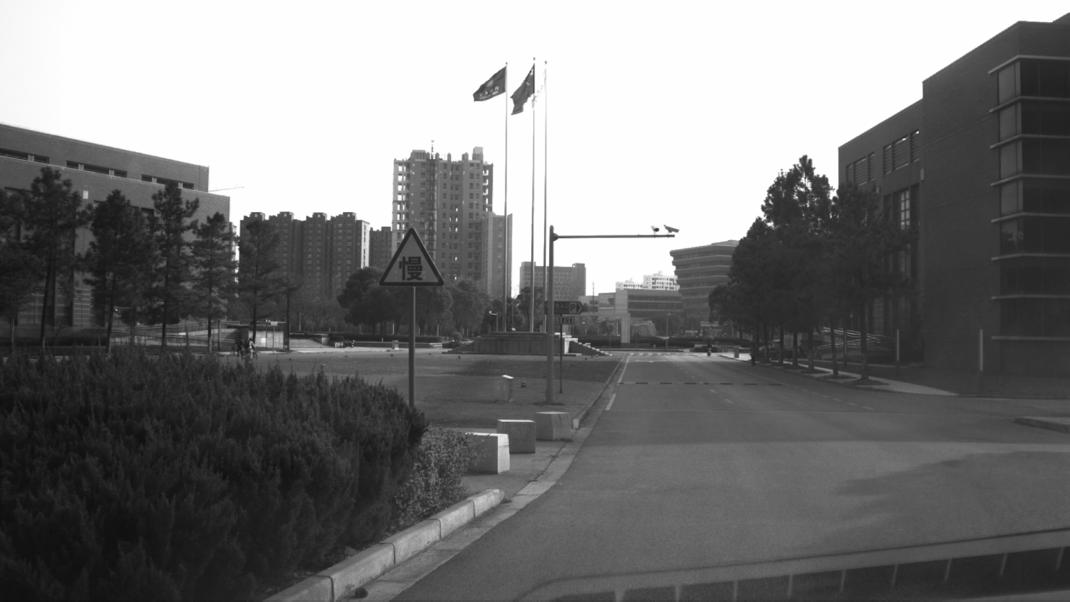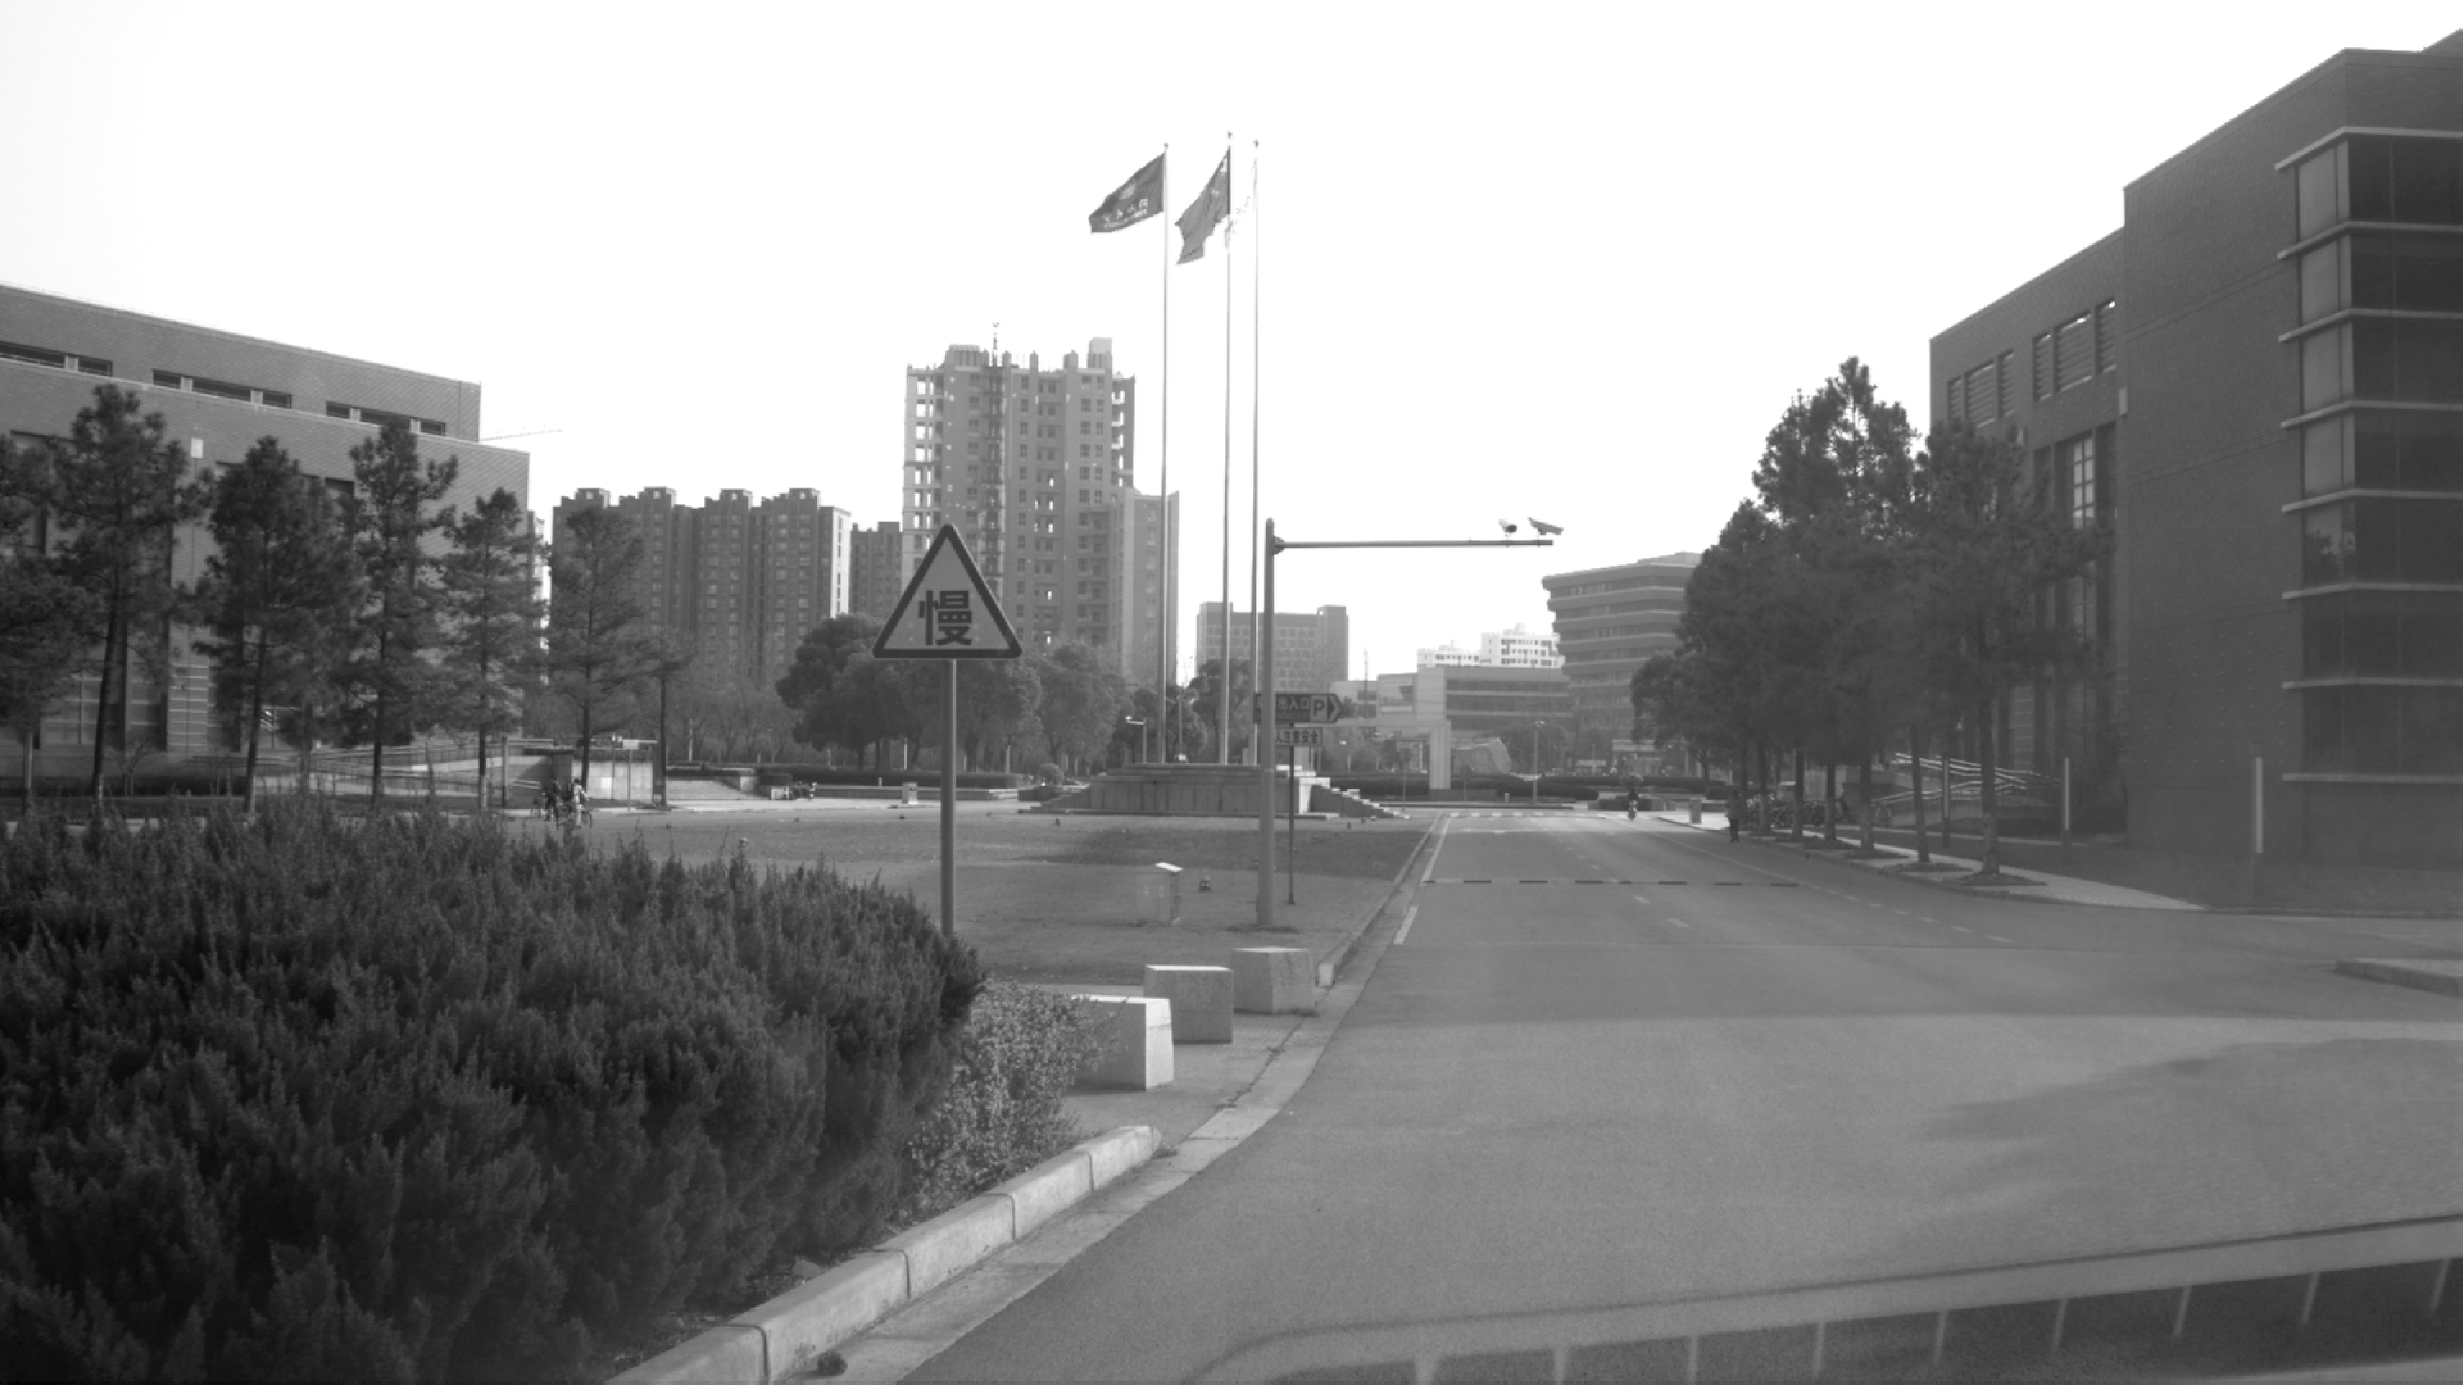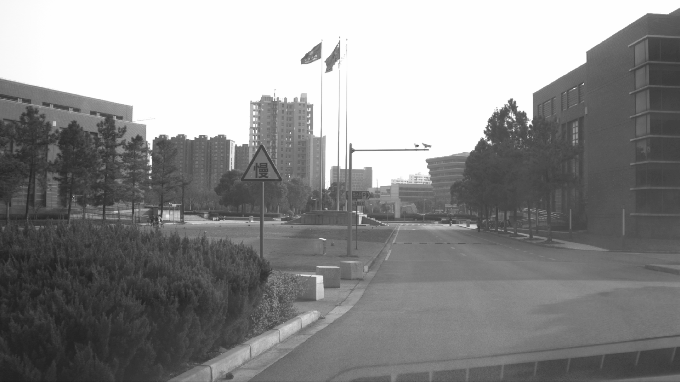We are able to test the recognition accuracies with the parameters *T* =840 and *S*=60, the results of CNN accuracies with different iteration numbers are shown in Table 4, in which the *I* represent Iterations and *A* means Accuracy. Clearly, the 150-epoch-iteration is verified to be the best.



|  |  |  |  |
| --- | --- | --- | --- |
| Training Data | Kernel | Accuracy | Time |
| 100% | RBF | 98.81% | 507s |
| 100% | Linear | 98.6% | 371s |
| 50% | RBF | 96.41% | 285s |
| 50% | Linear | 96.1% | 122s |

Table 4: CNN Accuracies of Different Iterations.



I (epochs) 100 150 350 500

A (%) 97.27 98.18 94.4 92.73

Briefly, the experimental parameters can be con- cluded in Table 5.

Table 5: CNN Experimental Parameters.



Kernel Size Batch Size I (epochs) 5×5 / 2×2 60 150

In order to optimize the classifying performance, we have trained the SVM classifier by libsvm package (Suralkar et al., 2012) (Chang and Lin, 2011) after removing fully connected layer. The output vector of the last layer in CNN is regarded as the input of the SVM. We are able to expand the normal classi- fier to solve the multi-classify problem, with training and connecting *k*×(*k*−1) normal classifier as the con-

2

struction of a binary tree, in which *k* represents the

number of classes. Kernel function is a key factor in constructing the SVM classifier. There are several kernel functions provided for us to select, e.g., RBF, Linear and Gaussian Kernel, with different parame- ters and outcomes. Taking 100% and 50% training data set as the experimental samples, we are able to conduct an experiment to choose the most suitable kernel function as Table 6. The overall training time and training accuracy are two factors to evaluate the performance of different functions.

From the point of training accuracy, the RBF ker- nel outperforms the Linear kernel. As the parameter number of RBF is more than Linear kernel, it will take times to find a better result. Based on large number of parameters, the training speed of RBF is obviously slower than the Linear kernel. Thus, the Linear kernel can be a more suitable choice for our model. In addi- tion, the Table 6 also illustrate that the SVM method is robust when the training data set is in a small scale. Because our data set only contains 1000 images, the 50% of them still show good performance.

(a) Original (b) Homomorphic (c) Gamma

Figure 6: Comparison between Homomorphic Filtering and Gamma Correction.

## Preprocessing for Testing

Before testing progress, we have to take some image preprocessing operations in street-view images to eli- minate the effect of insufficient illumination, partial occlusion and serious deformation. The main prepro- cessing operations include image enhancement and image segmentation.

Firstly, we need to deal with the images under a poor illumination. A typical method is the homo- morphic filter method (Cai et al., 2011), which uses a suitable homomorphic filter function *H*(*u, v*). In this method, the coefficients are *Hl <* 1 and *Hh >* 1, the function *H*(*u, v*) would decrease. Therefore, we are able to enhance the images by reducing the low fre- quency and increasing the high frequency. Another way is gamma correction (Huang et al., 2013), which compensates the deficiency in dim light. The Figure 6 shows a comparison of the homomorphic filtering as Figure 6(b) and gamma correction as Figure 6(c). Clearly, the former performs better, as the color of the testing image has a certain distortion after gamma correction.

In addition, the images with normal light will not be sent to the filtering process directly. To judge the predicable images, we can introduce the YCbCr color space, as the Y component represents the illumina- tion factor. We are able to select the thresholds by drawing the pixel distribution in histogram and coun- ting the pixel numbers (*a*), in images with extremely

light. After taking the experiments, the threshold can be determined by Y∈[200,234] and *a <* 53901.

Secondly, we need to take morphological treat-

ment before segmentation to eliminate discontinuous tiny areas. However, some obstacles in the street view have not been removed totally, for instance, the non- signs areas which are similar with the signs areas. Thus, we define the size and proportion of the traf- fic signs by experimental results. In addition, the one

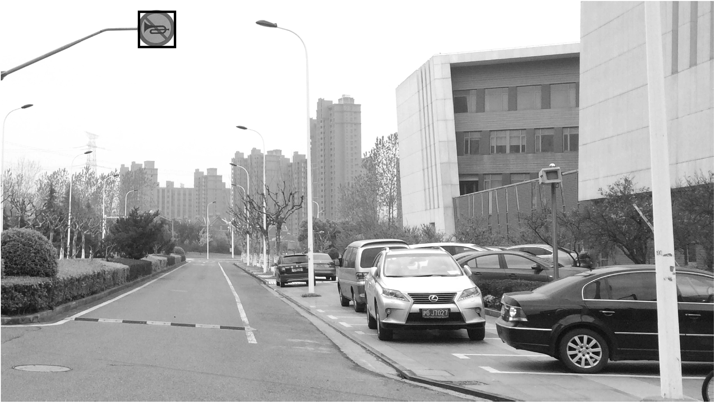 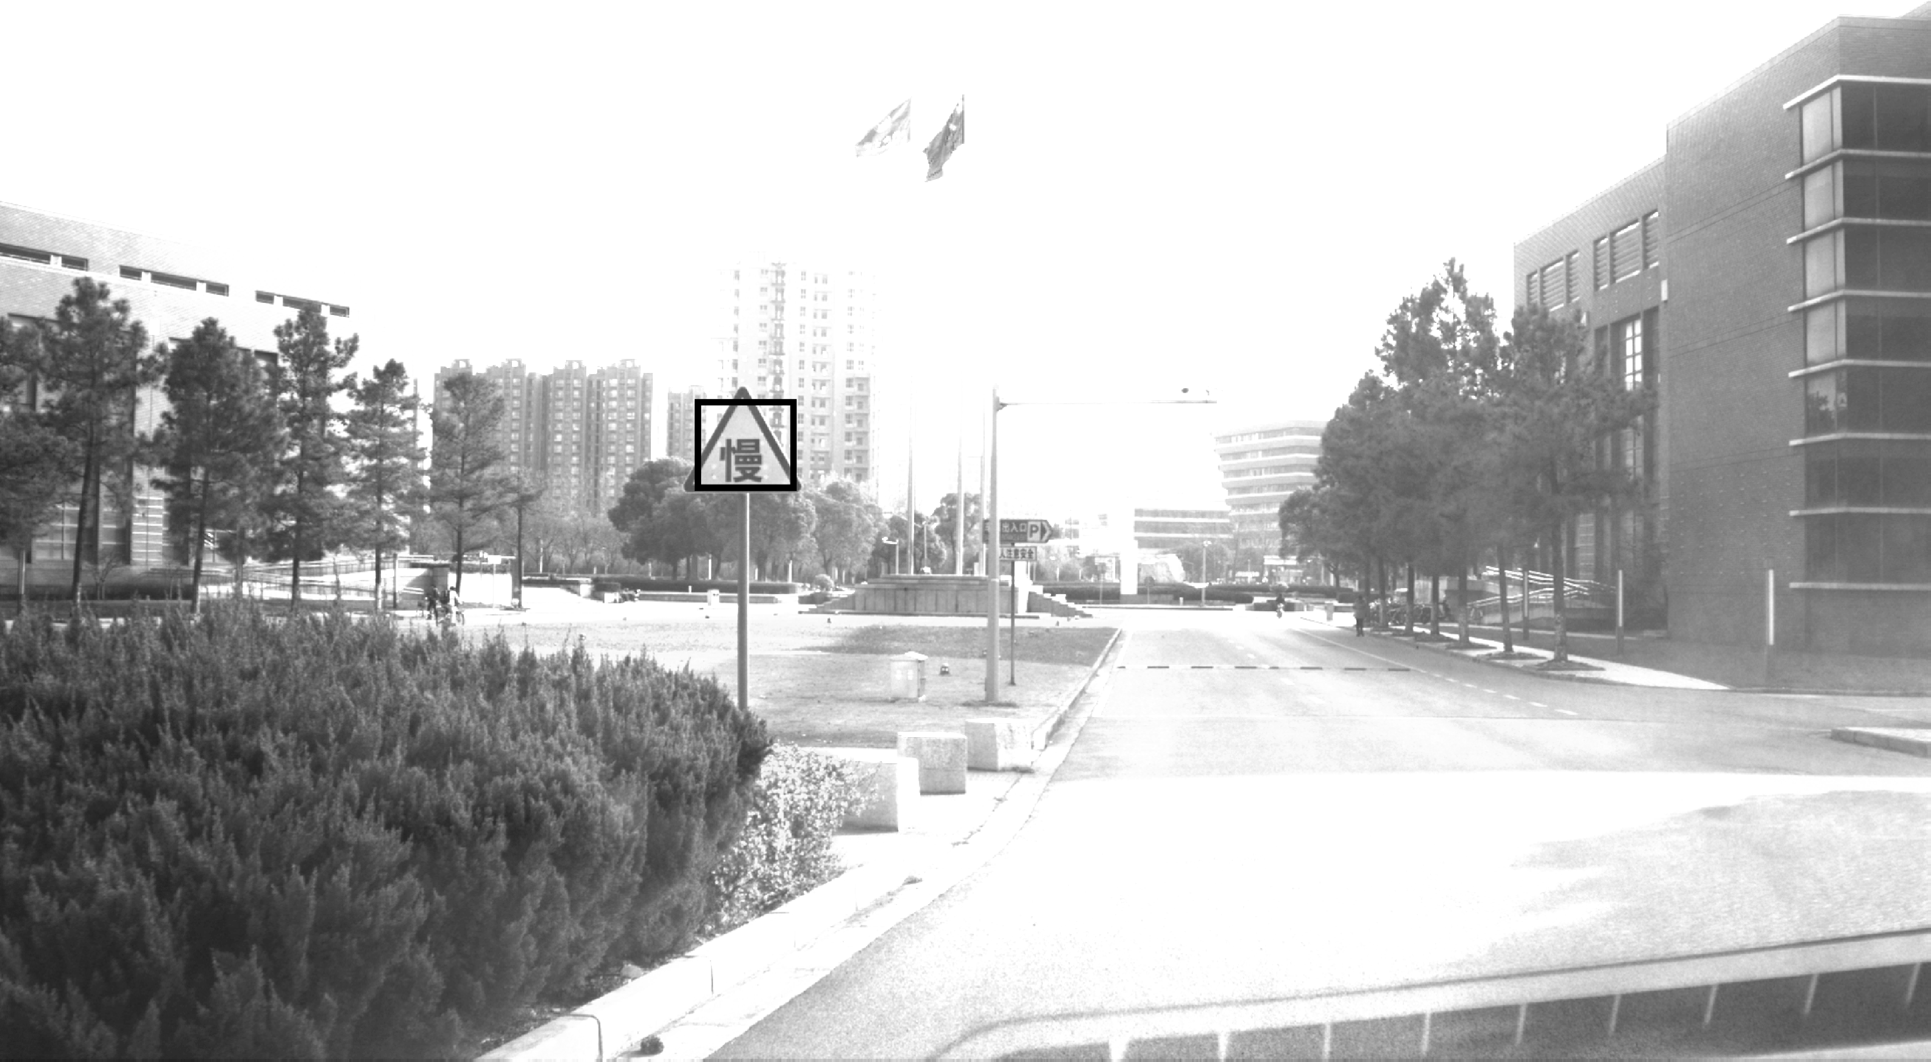 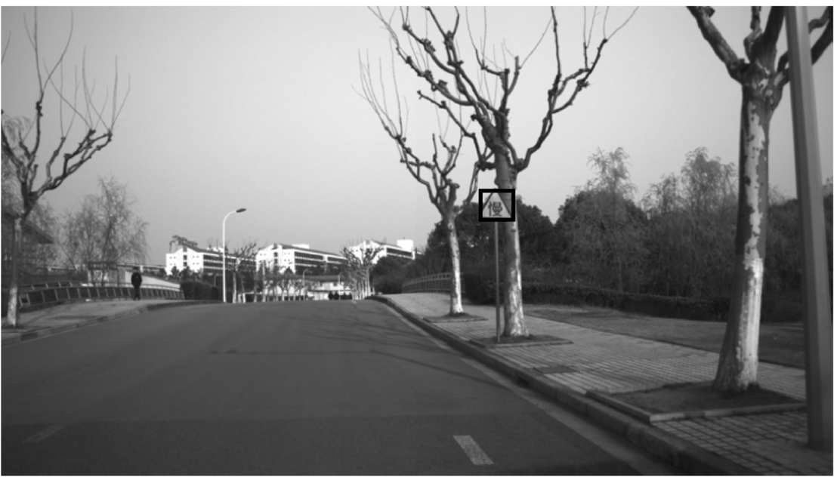 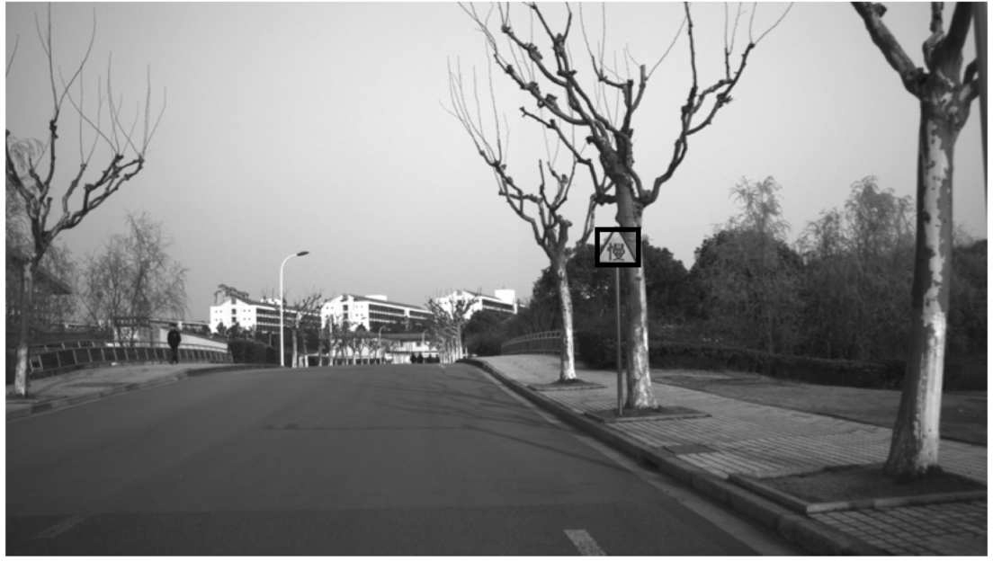

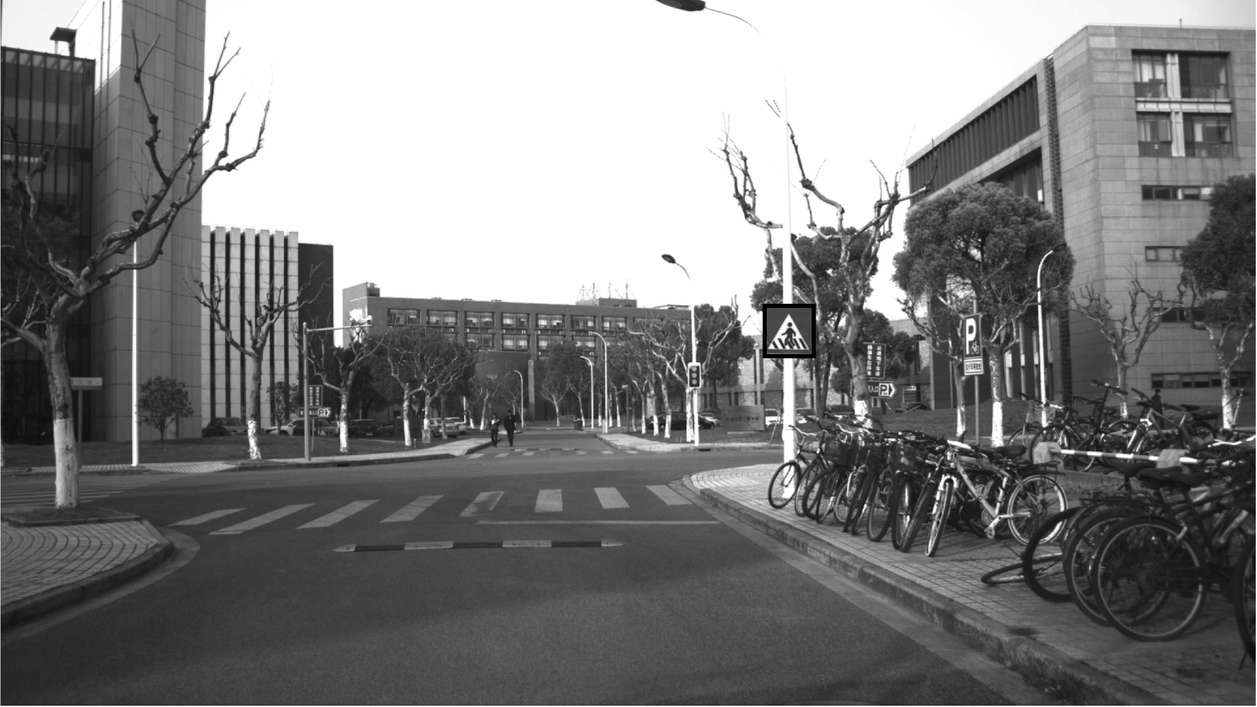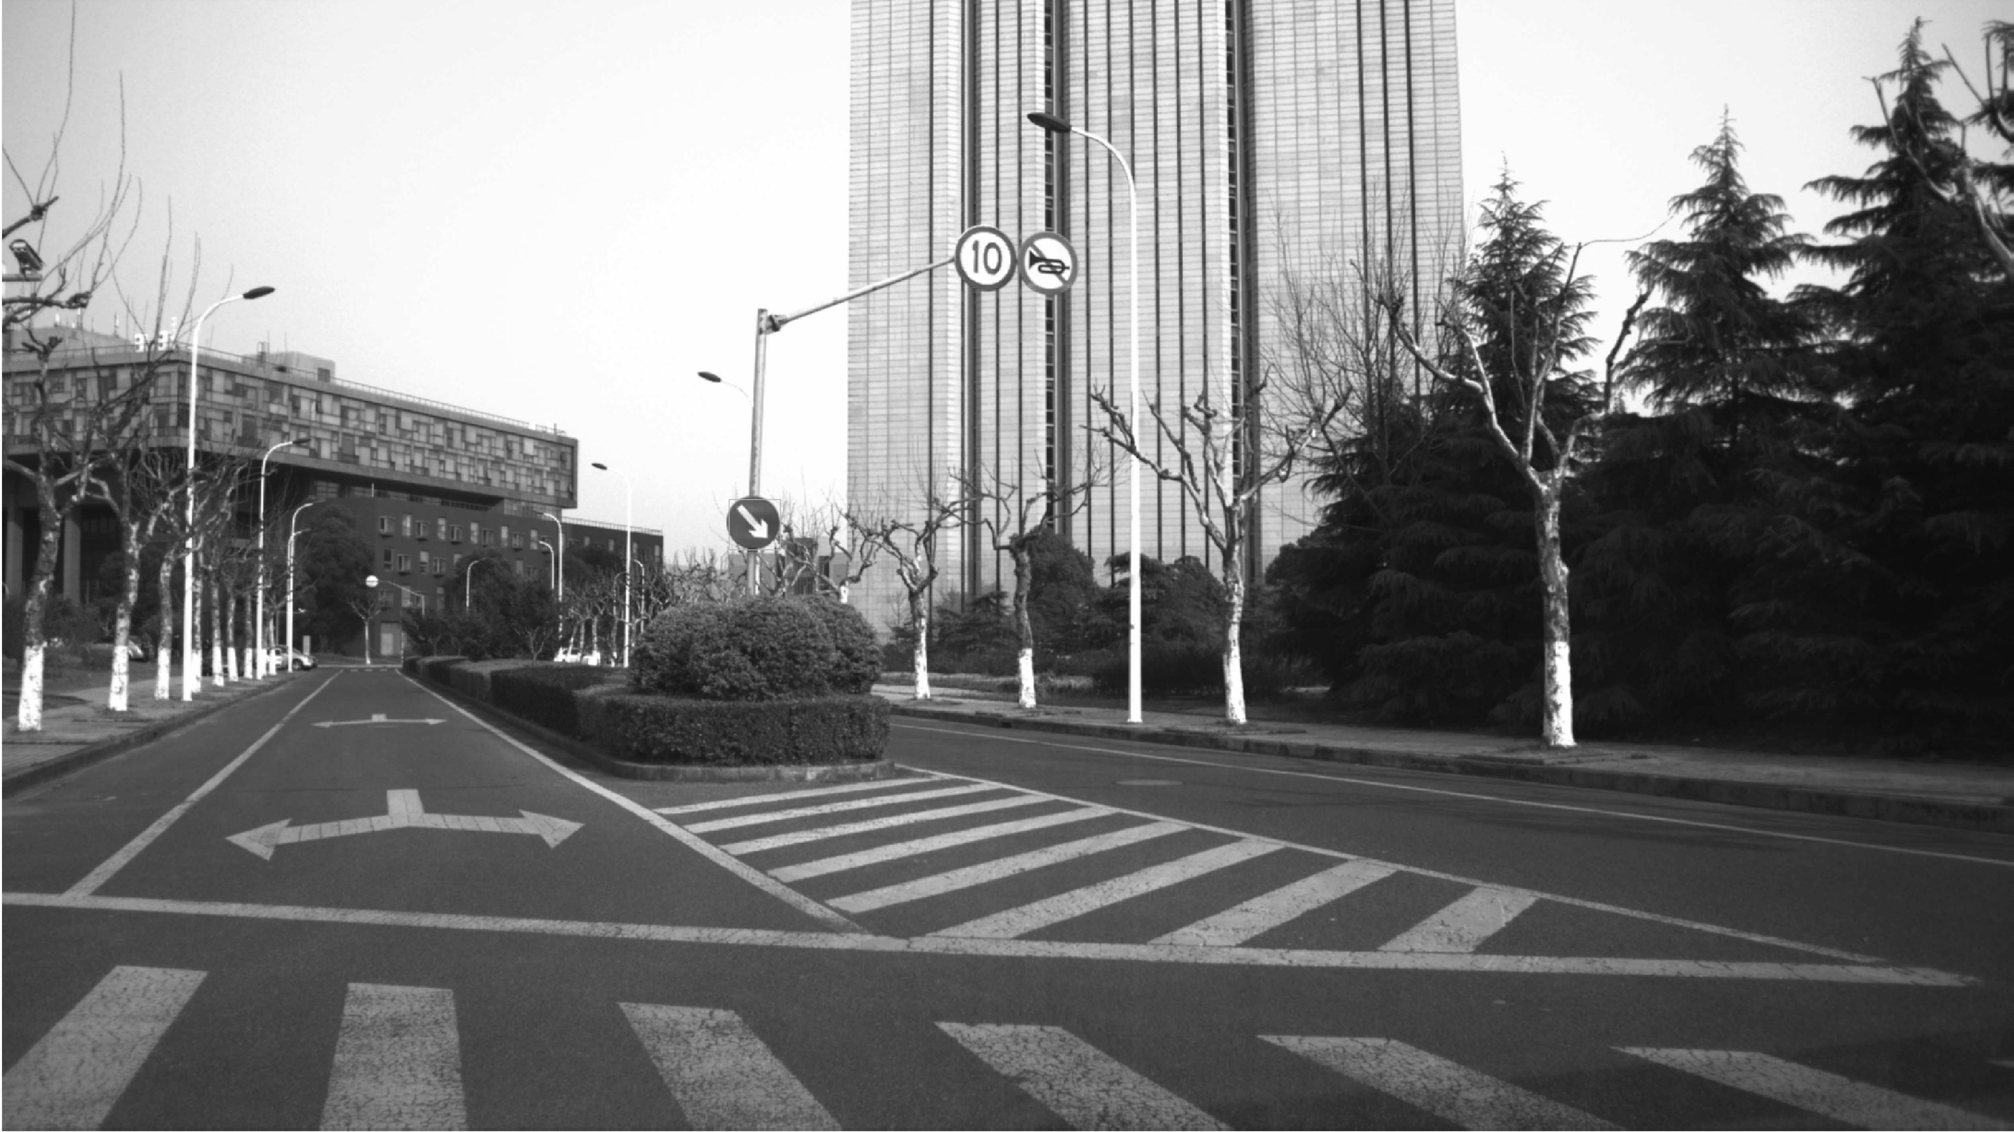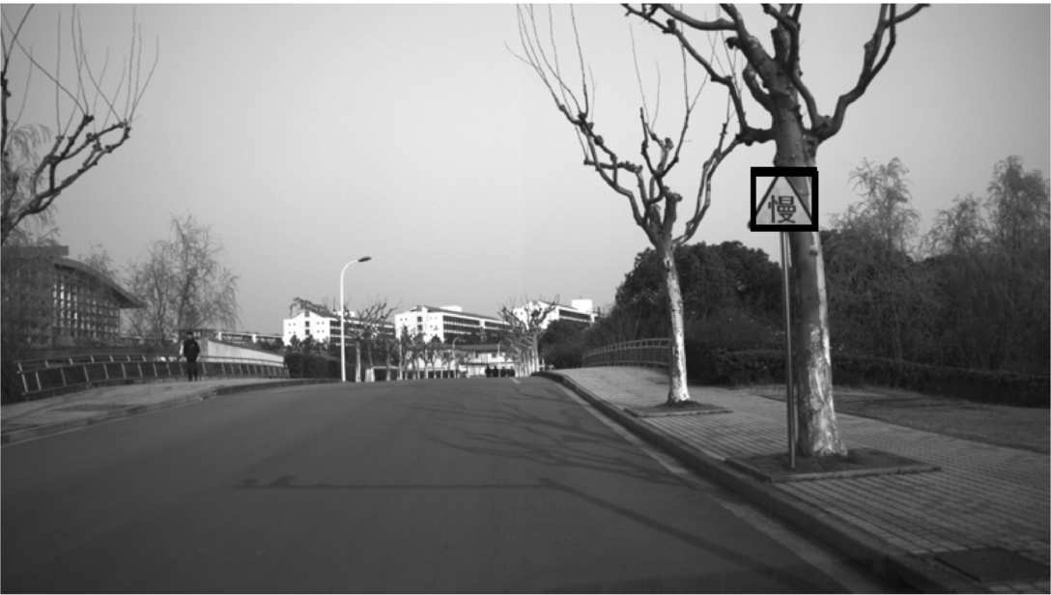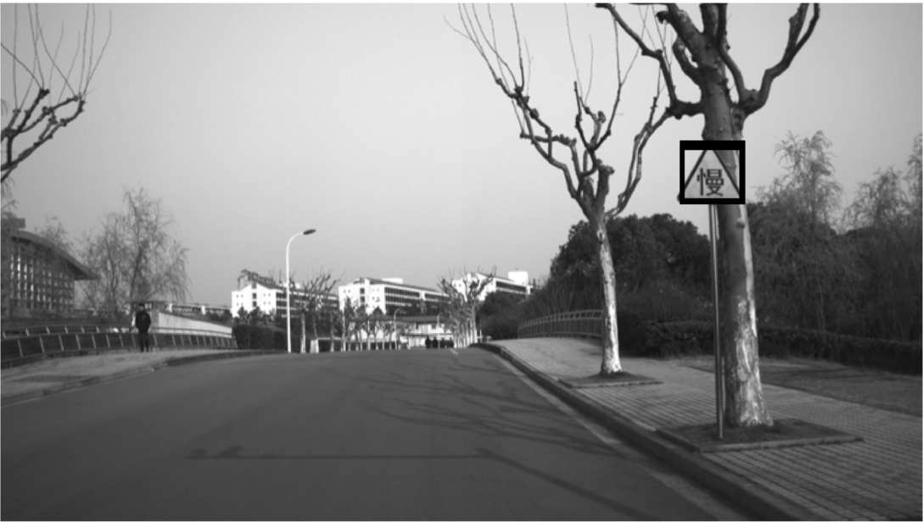

Figure 7: ROIs in Different Scenarios.

third part in the bottom image, where we set the pixel value to zero, would not contain any signs. Thus, the non-signs area can be removed.

Finally, the ROIs can be selected by a bounding box with fixed size and proportion in the whole street- view image as shown in Figure 7. Among these re- sults, we can find that the most of road signs are successfully recognized while some are ignored or double recognized.

# ANALYSIS OF EXPERIMENTAL RESULTS

In this paper, both training and testing were done on a Linux PC with an Intel i7-6900k CPU and NVIDIA GTX 1080 Ti GPU. The collected training data set is loaded and trained in our network. From the training data set, we randomly select 840 images as training samples, the rest as testing samples for cross valida- tion.

## CNN-SVM Recognition and Classiftcation Results

The CNN is able to detect and classify the targets, via extracting the training samples’ features. Then, SVM contribute to a better result in classification. With a number of parameter adjustments, the CNN is successfully trained with 98*.*18 % accuracy rate, while the CNN-SVM’s accuracy reaches 98*.*6 %. Even though the growth of accuracy is slight, the training time is very near from each other, with 366s and 371s respectively.

In addition, we take the mean shift method (Co- maniciu and Meer, 2002) to track the road signs in a short video as Figure 8. The figure shows that the ca- pabilities of this framework in detecting the tiny traf- fic signs which take a small area as 0*.*2 % 0*.*4 % of the whole image. The results of the recognition and classification of 8-classes road signs are shown in Table 7.

−

Figure 8: Tracking in Video by Mean Shift. From the upper left to the lower right sub-images represent the 1st, 3rd, 5th and 8th frame respectively.

Table 7: The Results of the Recognition and Classification of 8-classes Road Signs.



|  |  |  |
| --- | --- | --- |
| Classes | Total Numbers | CNNs-SVM(%) |
| Limit 30 | 109 | 97.34 |
| Limit 40 | 123 | 98.32 |
| Limit 50 | 141 | 98.7 |
| Slow | 136 | 98.9 |
| Crossroads | 134 | 98.56 |
| No tooting | 153 | 99.43 |
| Right | 138 | 98.46 |
| Straihgt | 66 | 96.6 |

## Comparison with State-of-the-Art Methods

The Figure 9 illustrates the comparison results with other state-of-the-art methods. It shows that our CNN-SVM method is able to achieve a higher accu- racy (98.6%) than the others, e.g., HOG-LDA (Stal- lkamp et al., 2012), HOG-Random Forest (Zaklouta et al., 2011) and PCA-SVM (Chan et al., 2015). Furt- hermore, the training time of our method (around 371s) is the fastest, which nearly twice as fast as the HOG-LDA.

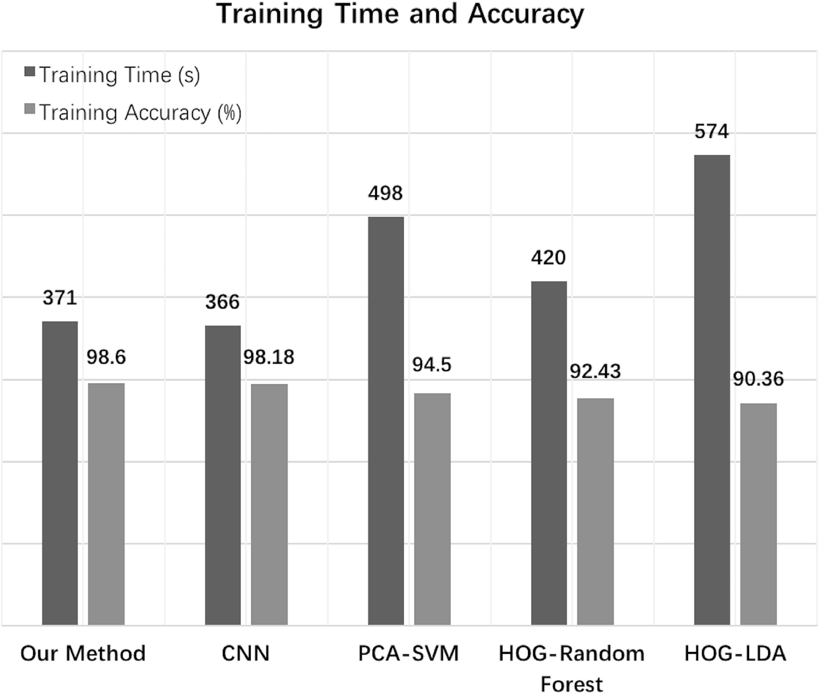

Figure 9: Comparison with State-of-the-Art Methods.

# CONCLUSIONS

In this paper, a recognition and classification method based on CNN-SVM has been proposed. In the trai- ning process, the deep image features are extracted by CNN in the YCbCr color space. SVM is con- nected with the last layer of CNN for further classi- fication, which contributes to a better training results. On the other hand, some images preprocessing pro- cedures are conducted in the testing process, in or- der to eliminate those negative impacts, e.g., insuffi- cient illumination, partial occlusion and serious de- formation. Experiment-based comparison with other state-of-the-art methods verify that our model is su- perior than the others both in training accuracy and speed. Furthermore, we found that some road signs are miss-recognized when we apply this method in the unmanned ground vehicle. In near future, we plan to expand our data set by seeking out more images of road signs, especially the images at night. Then, we will accelerate the speed by optimizing the algorithm for real-time application in vehicles.

# ACKNOWLEDGEMENTS

This work was supported by the National Natu- ral Science Foundation of China (NSFC), Grant No.61373106. The authors gratefully acknowledge everyone who helped in the work. *Corresponding author: Lan Lin.*

# REFERENCES

Basilio, J. A. M., Torres, G. A., Rez, G. S., nchez, Medina,

L. K. T., Meana, H., and Ctor, M. P. (2011). Explicit image detection using ycbcr space color model as skin detection. In *American Conference on Applied Mat- hematics and the Wseas International Conference on Computer Engineering and Applications*, pages 123– 128.

Cai, W., Liu, Y., Li, M., Cheng, L., and Zhang, C. (2011). A self-adaptive homomorphic filter method for re- moving thin cloud. In *International Conference on Geoinformatics*, pages 1–4.

Chan, T. H., Jia, K., Gao, S., Lu, J., Zeng, Z., and Ma, Y. (2015). Pcanet: A simple deep learning baseline for image classification? *IEEE Transactions on Image Processing A Publication of the IEEE Signal Proces- sing Society*, 24(12):5017–5032.

Chang, C. C. and Lin, C. J. (2011). *LIBSVM: A library for support vector machines*. ACM.

Comaniciu, D. and Meer, P. (2002). Mean shift: A robust approach toward feature space analysis. *IEEE Tran-*

*sactions on Pattern Analysis & Machine Intelligence*, 24(5):603–619.

Creusen, I. M., Wijnhoven, R. G. J., Herbschleb, E., and With, P. H. N. D. (2010). Color exploitation in hog- based road sign detection. In *IEEE International Conference on Image Processing*, pages 2669–2672.

Dai, J., Li, Y., He, K., and Sun, J. (2016). R-fcn: Object de- tection via region-based fully convolutional networks. Duan, J. and Viktor, M. (2015). Real time road edges de-

tection and road signs recognition. In *International*

*Conference on Control, Automation and Information Sciences*, pages 107–112.

Gidaris, S. and Komodakis, N. (2015). Object detection via a multi-region and semantic segmentation-aware cnn model. In *IEEE International Conference on Compu- ter Vision*, pages 1134–1142.

Girshick, R. (2015). Fast r-cnn. In *IEEE International Con- ference on Computer Vision*, pages 1440–1448.

He, K., Zhang, X., Ren, S., and Sun, J. (2016). Deep resi- dual learning for image recognition. *Computer Vision and Pattern Recognition*, pages 770–778.

Houben, S., Stallkamp, J., Salmen, J., Schlipsing, M., and Igel, C. (2014). Detection of road signs in real- world images: The german road sign detection ben- chmark. In *International Joint Conference on Neural Networks*, pages 1–8.

Huang, S. C., Cheng, F. C., and Chiu, Y. S. (2013). Ef- ficient contrast enhancement using adaptive gamma correction with weighting distribution. *IEEE Tran- sactions on Image Processing A Publication of the IEEE Signal Processing Society*, 22(3):1032–41.

Krizhevsky, A., Sutskever, I., and Hinton, G. E. (2012). Imagenet classification with deep convolutional neu- ral networks. In *International Conference on Neural Information Processing Systems*, pages 1097–1105.

Li, H., Lin, Z., Shen, X., Brandt, J., and Hua, G. (2015). A convolutional neural network cascade for face de- tection. In *Computer Vision and Pattern Recognition*, pages 5325–5334.

Liu, W., Anguelov, D., Erhan, D., Szegedy, C., Reed, S., Fu, C. Y., and Berg, A. C. (2016). *SSD: Single Shot MultiBox Detector*. Springer International Publishing.

Nassu, B. T. and Ukai, M. (2010). Automatic recognition of railway signs using sift features. In *Intelligent Vehicles Symposium*, pages 348–354.

Ouyang, W. and Wang, X. (2014). Joint deep learning for pedestrian detection. In *IEEE International Confe- rence on Computer Vision*, pages 2056–2063.

Redmon, J., Divvala, S., Girshick, R., and Farhadi, A. (2016). You only look once: Unified, real-time object detection. *Computer Vision and Pattern Recognition*, pages 779–788.

Ren, S., Girshick, R., Girshick, R., and Sun, J. (2017). Fas- ter r-cnn: Towards real-time object detection with re- gion proposal networks. *IEEE Transactions on Pat- tern Analysis & Machine Intelligence*, 39(6):1137– 1149.

Schmidhuber, J. (2012). Multi-column deep neural net- works for image classification. *Computer Vision and Pattern Recognition*, 157(10):3642–3649.

Sezer, V., anr Dikilita, Ercan, Z., Heceolu, H., ner, A., Apak, A., Gkaan, M., and Muan, A. (2011). Con- version of a conventional electric automobile into an unmanned ground vehicle (ugv). In *IEEE Internatio- nal Conference on Mechatronics*, pages 564–569.

Simonyan, K. and Zisserman, A. (2014). Very deep con- volutional networks for large-scale image recognition. *Computer Science*.

Stallkamp, J., Schlipsing, M., Salmen, J., and Igel, C. (2012). Man vs. computer: Benchmarking machine learning algorithms for road sign recognition. *Neu- ral Networks the Official Journal of the International Neural Network Society*, 32(2):323.

Sun, Y., Wang, X., and Tang, X. (2014). Deep learning face representation from predicting 10,000 classes. In *IEEE Conference on Computer Vision and Pattern Re- cognition*, pages 1891–1898.

Suralkar, S. R., Karode, A. H., and Pawade, P. W. (2012). Texture image classification using support vector ma- chine. *International Journal of Computer Technology & Applications*, 03(01).

Szegedy, C., Liu, W., Jia, Y., Sermanet, P., Reed, S., Angue- lov, D., Erhan, D., Vanhoucke, V., and Rabinovich, A. (2015). Going deeper with convolutions. *Computer Vision and Pattern Recognition*, pages 1–9.

Zaklouta, F., Stanciulescu, B., and Hamdoun, O. (2011). Road sign classification using k-d trees and random forests. In *International Joint Conference on Neural Networks*, pages 2151–2155.

Zeng, X., Ouyang, W., and Wang, X. (2013). Multi-stage contextual deep learning for pedestrian detection. In *IEEE International Conference on Computer Vision*, pages 121–128.

Zeng, Y., Xu, X., Shen, D., Fang, Y., and Xiao, Z. (2017). Road sign recognition using kernel extreme lear- ning machines with deep perceptual features. *IEEE Transactions on Intelligent Transportation Systems*, 18(6):1647–1653.

Zhu, Z., Liang, D., Zhang, S., Huang, X., Li, B., and Hu, S. (2016). Road-sign detection and classification in the wild. In *Computer Vision and Pattern Recognition*, pages 2110–2118.

629

[View publication stats](https://www.researchgate.net/publication/322881947)